**MAJOR PROJECT**

**Synopsis**

**Topic**

**Weather Forecast and Disaster Alarm in Hilly Area**



**B. Tech CSE AI& ML, 7th Sem, Batch: 2020-24**

**Section H**

**Submitted to: Submitted by:**

**Project guide: Mr. Ajay Kumar Umang Bansal 20BCRN024**

**Rahul Sharma 20BCRN022**

**Mayank Rajput 20BCRN068**

**Abstract**

India is at risk of numerous natural disasters due to its distinctive geo-climatic condition and geographical location. This landmass is encircled by water bodies on three sides and the chain of the Himalayas on the North. The country has been hit roughly by eight natural calamities annually, and there has been an increase in the frequency of natural disasters about five times within the past three decades. This results in losing thousands of human lives yearly, excluding the heavy damage to properties, animal life, etc., due to natural disasters.

In this project, we will take an input of live weather and the history of data collected on disasters in hills to warn about any disaster that may happen. This project will help us see the weather and if it’s safe to travel or stay in a hilly area, it will help analyze what type of impact the weather will have and warn accordingly. This will help detect the dangers in the mountains, saving countless lives. Our weather forecast and disaster alarm system aims to set an alarm that shows if it’s safe to stay in a place in the mountains or to travel. There are many levels of disaster analysis like floods, landslides, cloud bursts, forest fires, etc. In our project, we will primarily consider flood warnings. Our project aims to divide or distribute the dangers in hills according to their weather situations and helps the reader identify whether it’s safe.

**Keywords— Weather, disaster, safe.**

**Introduction**

Weather forecasts and disaster alarms use primary data analysis and computations to extract the weather readings. It is the processing of computationally identifying and classifying the weather in different areas in hills, whether it is raining or there can be floods or landslides and if the weather is clear. The weather forecast has a wide range of applications because it helps people to avoid certain conditions or disasters. We look at the weather, whenever we need to go somewhere, especially in disaster-prone areas. This project aims to check the weather and disaster analysis in hilly areas and tell if the place is safe to travel to.

We aim to perform disaster prediction on specific places in hills because disaster is more likely to happen in hilly areas as the weather changes. We will analyze the weather and disaster data from a reputed database and classify the weather as rainy, heavy rain, sunny, or clear for disaster, whether dangerous or safe, with the danger of floods. This project will help people to avoid potential catastrophes and travel safely in hilly areas. It will help residential people to be safe.

**For Ex: Weather: Heavy rain., Warning: It is not safe, Danger of floods.**

**This tells people that it is not safe to travel and to stay as there is heavy rain and danger of floods**.

Like this example, our project first will forecast the weather and analyze disaster readings of the place, and then, according to the data, it will examine if it’s safe or not or if there can be floods.

**Problem Statement**

Floods are now an annual nightmare in many parts of southern and western India. These floods appear to be getting more severe. Climate change is causing more substantial and erratic rainfall with recurrent floods in low-lying areas, while population growth puts more people in risky areas.

So, we decided to make a project on the weather forecast and disaster alarm which will display the weather conditions and then analyze the weather conditions and alarm people about any disaster that may happen. Through this project, although we can’t stop the disaster, we can warn people about the disaster so that proper measures like rescue operations can be taken before the disaster even happens to result in saving countless lives.

**Objectives**

Its main objective is to determine the weather conditions by analysing the data. Using thisdata, we develop an understanding of potential disasters that can occur and warn about them to the people to save their lives.

**Sub objectives:**

* + - To analyze the weather readings.
    - To determine the weather conditions by using the analyzed readings.
    - To display and read the weather conditions and confirm them with the existing disaster data.
    - To classify the data into danger of floods and safe

**Methodology**

The principle of the proposed system is as follows: First, the live weather data will be fetched by the API of the place entered by the user, then the data will be sorted in a table and then compared with another table using data mining algorithms, which will be contained our researched data on disaster readings, then we will analyze the data and alarm about any disasters that may happen.

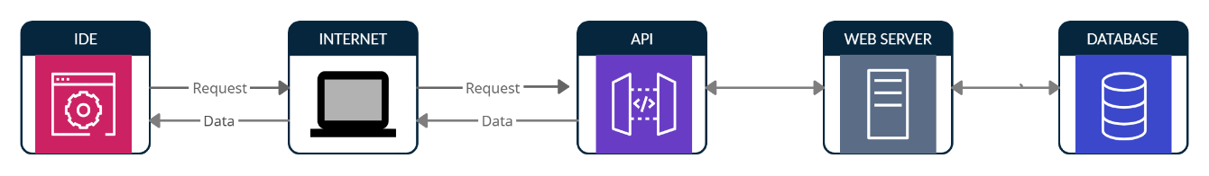

**Figure 1: Establishing connection through API call**

**Stages for an API call**

1. Request to API gateway.

2. Fetch information from the data server.

**Stages for weather forecast and disaster alarm:**

1. Display the weather data.

2. Sort the data in the table.

3. Analyse the data with the researched disaster data.

4. Alarm about the disaster.

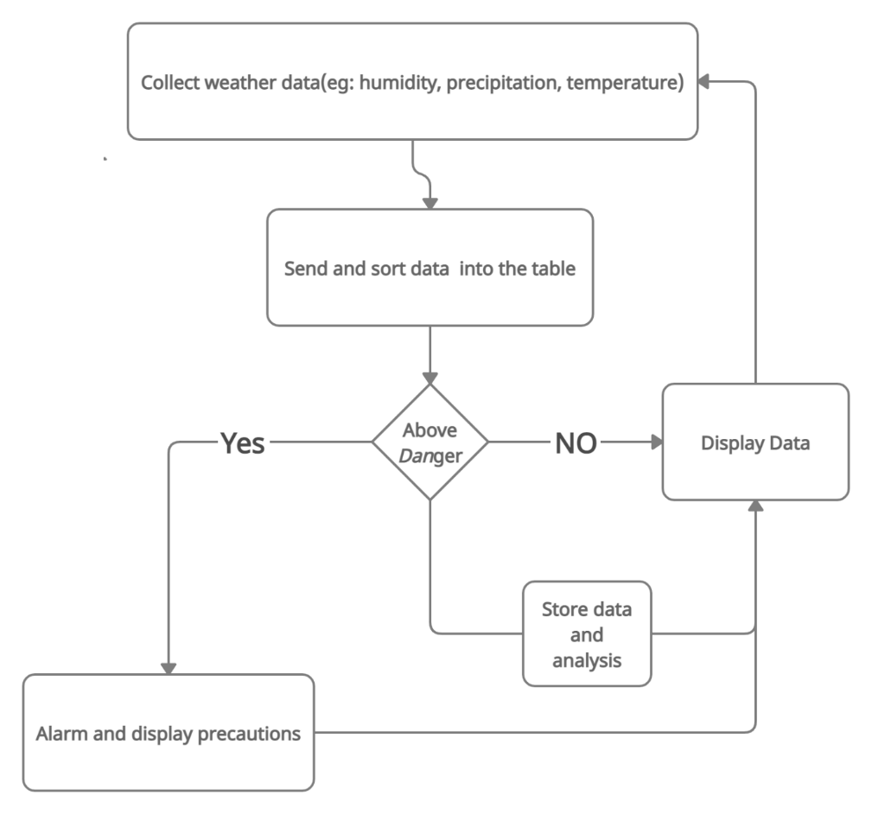

**Figure 2: Basic Workflow of the program**

**Use Case**

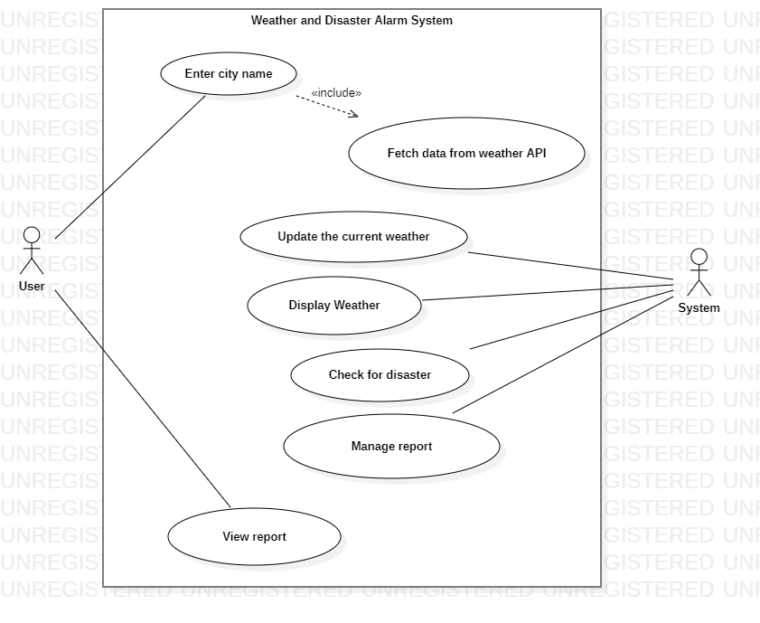

**Technology**

Languages

* HTML
* CSS
* Java
* XML

OpenWeatherMap API

Server- online database present for weather forecast.

**System Requirements**

Hardware Interface

* 64 bits processor architecture supported by any Operating System.
* The minimum RAM requirement for proper functioning is 512 MB.

Software Interface

* Operating System: Windows
* IntelliJ
* OpenWeatherMap API

**References**

* + <https://www.sciencedirect.com/science/article/pii/S2090447916000307>
  + <https://www.researchgate.net/publication/303436834_Flood_Disaster_in_Mountain_Environment_A_Study_of_Himachal_Pradesh_India>
  + <https://www.ipcc.ch/site/assets/uploads/2018/03/SREX_Full_Report-1.pdf>
  + <https://dmmc.uk.gov.in/files/pdf/Rudraprayag_final.pdf>
  + <https://dmmc.uk.gov.in/files/Impacts_of_Climate_Change.pdf>